  - English Schools Football Association (ESFA) National Cup: Round 5

Seaside success as sevens win at Scarborough
By Tom Carmichael – Macmillan Sports Correspondent
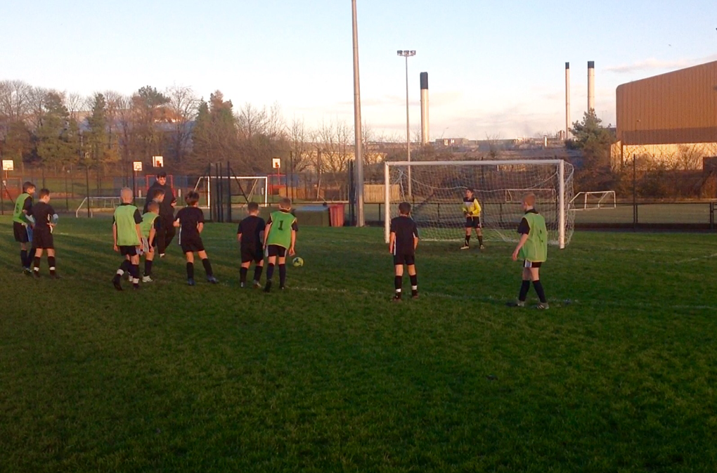

Preview:
As the National Cup gathers pace Mr Featherstone took his Year 7 side to Scarborough to face George Pindar School on Monday. After starting strongly in their debut season the team is half way through the gruelling nation-wide competition.

Wins against St Aiden’s and Acklam Grange see a team including Middlesbrough prospect Ajay Mathews brimming with confidence; and after defeating Northallerton in round five, hoping to be able to head back to Teesside with another win under their belts.

With a starting-berth being an elusive proposition, the team had worked hard during training to prepare for one of the academies biggest games in recent years. As for the match day setup, bulking the midfield was the main principle of Featherstone’s philosophy; the manager opting for a 3-4-1 setup with Dylan Thompson between the sticks and Mathews operating as the lone striker.

Having a flat layer of midfielders spanning the width of the pitch was designed to utilise the electric pace of Olly Samuels and Charlie Hardy, while providing a thick blanket of bodies to shield the rear lines; durability with ingenuity.

Match report:

With a heavy pitch underfoot Macmillan opted for a cautious start, keeping possession for the opening period of play. Reece Lowthian was given a chance to stretch his legs after the long bus journey and darted down the wing.

His progression was halted as he was scythed down in conjunction with the penalty area, giving Olly Samuels a chance to whip the ball into the box.

The resulting free kick was palmed away weakly by the goalkeeper and dropped onto the floor inside the area. A manic scramble was eventually cleared as Lowthian couldn’t hook the ball towards goal.

As the ball was punted away from danger Ruben Hartley collated the ball for the hosts, he drove towards goal on the counter attack. A goal looked inevitable but credit must be given to Dylan Thompson who spread himself well and forced the shot to bobble wide.
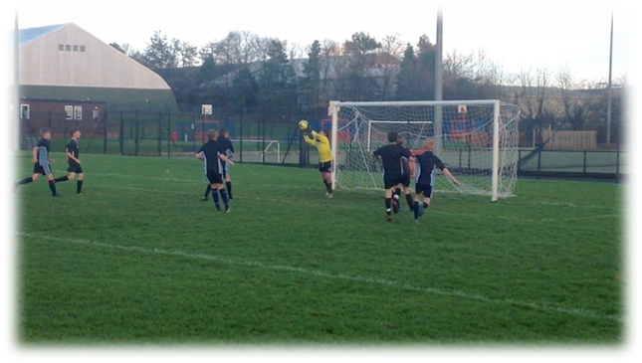

Samuels’ looping free kick was beaten away tamely by the goalkeeper before a melee in the box.

After Featherstone’s men had been let off the hook he urged them to push forward. Charlie Hardy’s cut back gave Mathews a chance on the swivel but the latter was unable to capitalise on Macmillan’s best chance so far, dragging his low shot just wide of the upright.

Mathews’ bright start was almost rewarded with an opening goal moments before George Pindar took the lead.
Despite being relatively even early on there had been chances and a goal looked on the cards. George Pindar forward Hartley picked up possession on the edge of the area and managed to manoeuvre a way around winner Montage.

Hartley was left with a great opportunity and took aim, firing a shot towards the bottom corner. The ball struck the woodwork on route to goal as the shot cannoned off the post and into the net.

This Macmillan setback was promptly followed by a stoppage in play, the home side putting on bibs after an early clash of kits had led to some confusion. Featherstone took this opportunity to clump his men together and get them back into the right frame of mind after just conceding.

However, this response wasn’t quite as instant as the head coach may have hoped; Goalkeeper Thompson once again left in a sticky situation. Once again though he was alert, bravely preventing a chipped shot by smothering the ball with his body to deny the hosts a second goal which would have doubling their advantage.

Another golden chance then presented itself for Mathews, with the equaliser beckoning the ball skewed up off his boot from point blank range.

After Samuels’ great ball in the goal was gaping as the delivery had took both goalkeeper and recovering defender out of the game. But as the Middlesbrough man looked to adjust his body he got it horribly wrong and squandered a great chance to pull Macmillan level.

Another melee couldn't prod the ball home as a posy of bibbed shirts clambered the ball away to safety. Macmillan’s reluctance to pull the trigger meant they were struggling to capitalise on opportunities, leaving both players and coach frustrated.

However, the homes sides’ frustration was their downfall as Olly Sampson was hacked down in a similar position as previous in the match. He stepped up and produced an unbelievable strike from mass range, the ball sailing over everybody and into the net to haul Macmillan back on level terms.

Olly Samuels’ goal was his third free kick of the match at that point after going close on two previous occasions.

This goal reinvigorated the away players and when Mathews squared the ball across goal for Hardy the wide man everyone thought the net was about to bulge. As it was though the ball flew wide.

Macmillan were starting to turn up the heat and move through the gears. Lowthian made home legs trembled even more moments later as his curving effort from just outside the area was millimetres away from goal. His powerful drive left unrewarded but playing on the heart strings of those from a George Pindar persuasion.

Mathews was busy again moments later, collating the ball in the Pindar half, he twisted and turned to open up a route towards goal. On reaching the penalty area he unleashed a venomous pile driver of a shot into the roof of the net leaving the keeper grasping thin air.

In taking the initiative for the first time in the game Macmillan pushed on looking for a more comfortable position heading into the break.

Hardy’s through ball allowed Mathews to beat the offside trap and his darting run left him baring down on goal. Keeping his cool, the ‘Boro’ man slipped the ball under the goalkeeper and over the line to give Macmillan precise breathing space in such a pivotal National Cup tie.

At 3-1 Macmillan were awarded a penalty kick. Tenacious play from Mathews saw him receive a scrumptious reward as a tug back in the penalty area saw the referee point to the penalty spot. Unfortunately he couldn’t add to his goal tally and complete the hat-trick as his spot kick skimmed the cross bar and powered away across the field. An opportunity squandered for Featherstone's side to gain some additional breathing space.

The final action of the half saw the home side took the initiative from that point and Macmillan were given a let off when a prodded shot from around five yards out whistled past the post.

The second half had a feisty start as Mathews was hauled down violently. The resulting free kick could not muster up anything bad was eventually cleared away by the hosts. This rugged and vicious start set the tone for a turbulent second half.

Macmillan won another free kick minutes after and Pindar were made to pay the price for their ill-discipline as Elijah Payne glanced home the header to add fuel to the fire.

A lengthy stoppage in play came about soon after this latest goal. Macmillan goalkeeper Dylan Thompson went down under challenge and appeared to have strained his foot. With no recognised replacement on the bench Reece Lowthian was forced to jump in.

Although he had little time to acclimatise to his new surroundings as he was forced into a great reflex save just moments in to his second half tenure between the sticks.

Mathews then had another chance presented to him, bearing down on goal the goalkeeper rushed out to meet him and the striker was put off, placing his shot marginally wide.

The hosts did try to close the gap and pulled a goal back through Coulby Wilson, a fine finish which skimmed along the turf and past the deputising Lowthian in goal, who couldn't get down quick enough on the boggy terrain.

Mathews was again bundled down in the box and had a chance to redeem himself and complete his treble from the penalty spot, the shot was closer this time as it struck the cross be and bounced onto the turf. Michael then headed the rebound back onto the crossbar for a second time before Ajay toe poked the ball over the line. Michael was in an offside position but claimed to have not touched the ball and the goal was given.

After play restarted the hosts took issue and an angry outburst of tackles forced the games second stoppage period. The home side called in to be disciplined.

Mathews’ final venture allowed him to score his forth. Running rings around the defender one last time after timing his run after receiving the touch on from Callum Crutchley who’d done great off the bench. The initial shot from Mathews was charged down but Ajay collated the ball and turned his man to riffle home.

The hosts hit a shot over the crossbar clipping it on the way through but that late miss all but extinguished any potential late response and guarantee the victory for Featherstone’s men and secured their progression to the sixth round.

Match statistics:

 | George Pindar | Macmillan Academy
Goals | 2 | 6
Shots | 8 | 14
Shots on target | 5 | 8
Corners | 2 | 4
Fouls | 10 | 4
Possession | 45% | 55%

Analysis:

Man of the match: Ajay

Mathews was up against play right from the word go. Seen here on the right he matched the George Pindar defenders for fight, aggression and determination and battled for every ball. This juxtaposed with his eloquent passgaes of play which saw him drift into goal scoring positions time and time again.

One improvement for the Middlesbrough forward would be to practice his penalty taking skills, although he deserves credit for reacting to knock the ball home at the second time of asking

Ajay Mathews: Key runs

Mathews’ movement created goal scoring chances as well as space for other players. His dangerous prowess magnetised Pindar defenders to him, freeing up room for the likes of Olly Samuels and Charlie Hardy.

Balanced midfield dictates flow of game:

A cocktail of different types of players has been moulded and blended together nicely by Featherstone. The hearty challenges of Michael Obrien add depth and tenacity to the team. He battled well throughout the entire duration of the sixty minutes as shown on the right.

Alongside this the North Ormsbey man has the ability to pick out teammates with his great range of passing, allowing him to regain possession and link up the play.

Contrastingly, Olly Samuels, and Reece Lowthian offered a Kevin De Bruyne type midfield composition. The two were accurate in their long range passing and their vision to open up the play allowed the free flowing runs of Ajay Mathews to be connected. Samuels in particularly impressed with his free kicks as he gained a goal and two assists, while Lowthian was equally as impressive before switching to put the gloves on and fill in for the injured Dylan Thompson.

Olly Samuels was always on the move and his creative spark left defenders with no option but to chop him down to the floor.

Out wide Charlie Hardy and Callum Crutchley impressed in carrying the ball and driving forward to swing balls into the box as well as recovering to assist the back three when required.

Charlie Hardy helps out defensively after a Macmillan corner is cleared away to a safer remit.

Macmillan keep heads in physical match:

The back three worked well and understanding will grow over time. Interestingly, the height at the back allows for an additional threat at offensive set pieces, which Elijah Payne demonstrated when scoring his headed goal.

At the base of the team the triadic structure was successful and all of Featherstone’s defenders were disciplined and cautious with their tackling, which pleased the manager as this was at the host’s detriment, as they were punished for committing a series of rash challenges.

